(Approx. 414 words)

Open Source Lab
The End is Near (for Windows® 7) What about Linux?
By Cal Esneault, former President of and leader of many Open Source workshops
February 2019 issue, CCCC Computer News
www.clickers.org
tsa70785 (at) gmail.com

Traditionally, Microsoft Corp. released a new Windows operating system version every 3 years and supported each version for 10 years. The very popular Windows 7 release will reach the end of extended support on January 14, 2020 (next year!). Although many PC users have switched to Windows 10, over a third of PC users are still running Windows 7. If you still have Windows 7 and do not want to purchase a new computer, you could upgrade to Windows 10 for a fee (~ $139), but you also need to consider your PC capability. I have found that you need something newer than a Core Duo processor and 4 GB of RAM if you want an acceptable speed.

Many casual users today have discovered that smartphones and tablets meet their browsing and communication needs. To continue to use a less capable PC for special needs, now may be a good time to consider switching to a Linux system available at no cost. At our club, we suggest Linux Mint with the Cinnamon desktop. It is a modern graphical system with lots of similarity to Windows 7. In addition, it comes pre-loaded with lots of free software covering most basic needs (see screenshot below).

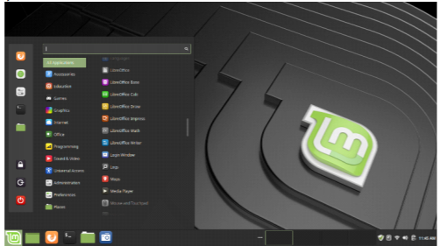

If the pre-loaded programs don’t meet your needs, there are thousands of additional applications available at no cost using the supplied software manager (see screenshot below).

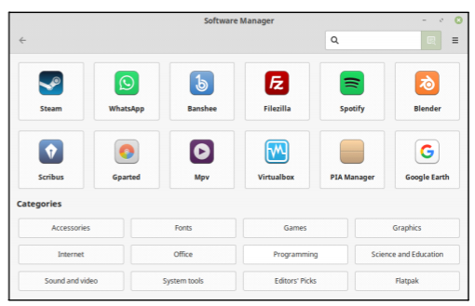

To verify that Linux will work on your equipment, you can make a “live” USB or DVD drive as a test without making any changes to your existing installation. First, install from the Internet a suitable program to make the “live” drive (for example, “Rufus”). Then, download a 64-bit “iso” of the latest Linux Mint. Using the downloaded utility, install the Linux system on the detachable hardware. With the Linux drive attached, at start-up immediately switch to the BIOS menu (search the Internet to find the proper key to press) and change the boot order to load the live system first.

After boot, you will be running Linux using your attached drive (no interaction with your existing system). You can test your hardware at this point and evaluate the Linux system. Upon shutting down, remove the temporary drive. Then reboot back into Windows 7 and consider your future options.

